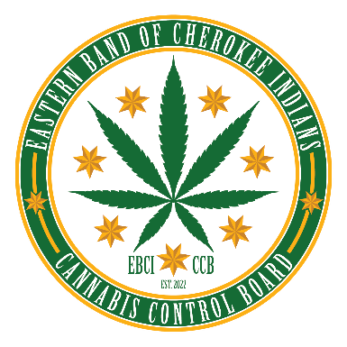

IMPORTANT INFORMATION ABOUT MEDICAL CANNABIS PATIENT CARDS
Please read this information carefully and contact the EBCI Cannabis Control Board (CCB) if you have any questions.

What does it mean to have a medical cannabis patient card?
Having a medical cannabis patient card means you will not be prosecuted by the EBCI Tribal government for possession of cannabis as long as you are possessing the cannabis in accordance with Tribal law. You will be able to purchase medical cannabis from dispensary locations on Tribal lands that are licensed by the CCB. A medical cannabis patient card does not prevent or act as a defense to prosecution by the Federal or North Carolina state government.

Where does EBCI Tribal law on medical cannabis apply?
The Tribe’s laws on medical cannabis only apply on Tribal law (the Qualla Boundary and the Tribe’s other trust lands). The laws do not apply to the parts of North Carolina that are not Tribal lands.

How long is a medical cannabis patient card valid?
One (1) year from the date of issuance.

Does a medical cannabis patient card allow me to take medical cannabis off of Tribal land?
No. Cannabis is still illegal under the federal and North Carolina law.

Does a medical cannabis patient card allow me to grow cannabis off of Tribal land?
No. The Tribal laws regulating medical cannabis do not apply off of Tribal lands.

What about medical cannabis and my health conditions?
The CCB does not practice medicine or provide medical advice. Please contact your doctor or medical care provider if you have questions about how cannabis could affect your health or interact with your other medications. Please do not consume cannabis if you are pregnant.

What about medical cannabis and driving?
A medical cannabis patient card is not permission to consume cannabis and drive. Do not consume cannabis and operate a motor vehicle or any other dangerous equipment. A medical cannabis patient card is not a defense to impaired driving.

Where can I purchase medical cannabis?
A cannabis dispensary will be operated by Qualla Enterprises, LLC. Please visit https://quallallc.com/ or email info@quallallc.com for more information.

Can I sell or give my medical cannabis to someone else?
No. You are not allowed to sell or give medical cannabis to anyone who does not also have a medical cannabis patient card.

Is the CCB responsible for my medical cannabis use?
No. You are obligated to use your medical cannabis patient card in accordance with the Cherokee Code and all other applicable Tribal laws.

How do I contact the EBCI Cannabis Control Board?
You can reach the CCB by email at info@ebci-ccb.org, by telephone at 828-229-8650, or visit the CCB Office at 620 Casino Trail, Whittier NC 28789 (Monday to Friday during business hours).

